 | “Afternoon Tea”  In memory of Dave Albert  Saturday 24 July 2021 | 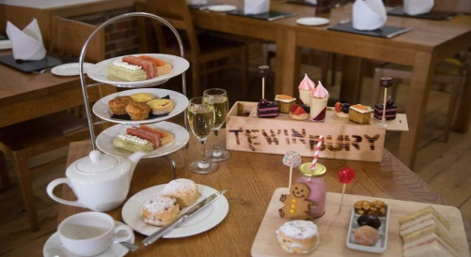

You are invited to join Cranmog friends for Afternoon Tea at Tewin Bury Farm Welwyn, or an alternative venue of your own choice nearer your home. This event is being organised in memory of Dave Albert who was a very supportive member of Cranmog and who unfortunately died earlier this year. Dave’s family is very pleased and supportive of this event.
Dave and Ann have been members of Cranmog and MSCC for many years and you will all know how much they both enjoyed and supported club events from national to local level in all parts of the UK and beyond.

No matter where you live, you are invited to participate in conjunction with the following arrangements: -

- Members local (ish) to the Welwyn area - Afternoon Tea will be arranged for participants local to Tewin Bury Farm, Welwyn. See details below and images overleaf.

- Members not local to the Welwyn area - are invited to make their own arrangements for Afternoon Tea local to their home area. See ‘Non Welwyn Arrangements’ below.

Tewin Bury Farm Arrangements

- Plan your own scenic drive starting whenever you wish. Perhaps a visit to your favourite NT property or other places of interest, or even a visit to one or two Morgan Dealerships.

- Aim to park up at Tewin Bury Farm between 2.45 & 3.15 pm and make your way to the Cowshed - see Timing (*) below.

- From here you can admire the views over local countryside while you enjoy:-
  - freshly made sandwiches,
  - homemade scones with cream and jam,
  - homemade cakes,
  - plus endless tea of your choice,
  - perhaps stretch your legs in the grounds and take a few snaps before heading home after an enjoyable afternoon.

- Dave was not one for fuss so no speeches are proposed, but at 4.15pm everyone will be asked to drink a ‘Toast to Dave’.

Non-Welwyn Arrangements.

- Very similar to the above, but please select your own destination for Afternoon Tea and plan your own scenic drive starting whenever you wish and concluding wherever you choose.
- Please aim to park up at your destination by at least 4.00pm so giving you time for a remote ‘Toast to Dave’ at 4.15 pm.
- After the event you will be most welcome to share with others details of your destination and snaps of your Afternoon Tea.

Timing (*) (for Tewin Bury Farm participants only)

- Your Afternoon Tea will be served in the new refurbished “Cowshed” on a ‘continuous flow’ type of basis in accordance with whatever time you arrive. If you wish to sit with specific friends then we suggest you agree to meet up in the car park and then enter the Cowshed as a group.

Next Steps and Booking Arrangements

- Please complete the Booking Form overleaf for Driver and Passenger(s) and return it asap but definitely by no later than 26 June, as places may need to be allocated on a FCFS basis. Like most Cranmog Events – we advise on booking early.

