“Afternoon Tea”
In Memory of Dave Albert
Saturday 24 July 2021.
BOOKING FORM

Driver’s Name |  | Passenger Names
Mobile number |  | Mobile Number
Tea Location? | - State if you wish to book Tea at Tewin Bury Farm, or  - If you intend to make your own booking at a Non-Welwyn location of your own choice. |  | - Welwyn  or  - Non Welwyn  (delete one of the above)
Food Allergies!  Confirm name of any individual who has any food allergies that you want Tewin Bury Farm to be aware of in advance | Item(s) to be avoided |  | Name
 | Item(s) to be avoided |  | Name
Payment for Afternoon Tea: | These are as follows:-  - No money to be paid to Cranmog or to the Event Organiser.  - Welwyn participants - When Stephen confirms receipt of your booking form you will be asked to contact Tewin Bury Farm by telephone and provide your name as being in the “Cranmog Group” and make full of £25 per person.  - Non-Welwyn participants - Book your tea the location of your choice & pay.
Please send this Booking Form asap but no later than 26 June to: | stephen@iiyc.co.uk or  Post to Stephen Isherwood, 32 Thomas Drive, Newport Pagnell, Bucks,MK16 8TH  Any questions please call Stephen on 07831 - 494423.
Covid Secure | This Event will be organised in compliance with the Covid 19 Government Guidelines relevant to our type of event and applicable for Saturday 24 July.  Further details of these will be confirmed closer to the date, though you are most likely to be fully aware of these beforehand through national press and media.
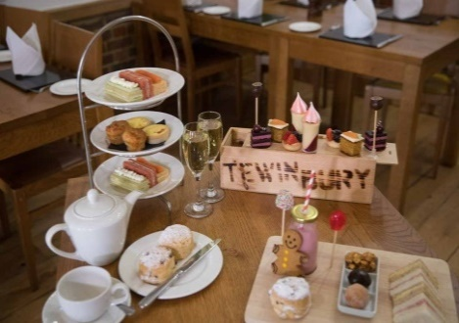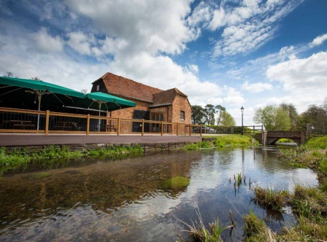

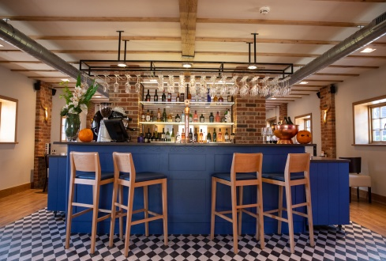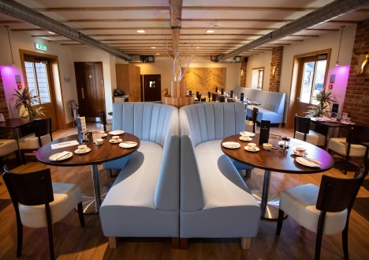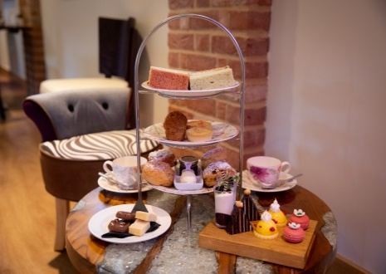

We look forward to your support for an enjoyable Afternoon Tea in memory of Dave
at Tewin Bury Farm, or a location of your choice.

