Entry Number

“THE JIM BARRY MEMORIAL RUN”

& STILTON CHEESE CLASSIC VEHICLE EVENT

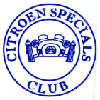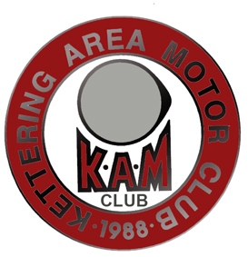 SUNDAY APRIL, 28TH 2019
IN CONJUNCTION WITH THE
FEDERATION OF BRITISH HISTORIC VEHICLE CLUB’S

“DRIVE IT DAY”
THE KETTERING AREA MOTOR CLUB
and the
THE CITROEN SPECIALS CLUB

Driver’s Name

Passengers’ Name(s):

Address:

Post Code:

Telephone Number: Mbl:

Email

Your Vehicle Make: Model :

Year Registered: Registration No

£
Number of Adults in party: (Cost per adult: £2.50) Total Cost :-

(under 16’s go free):
Cost per vehicle :-
£ 2.00
£
Late entry fee (£5 Where applicable)
£
GrandTotal :-

Please make your cheque payable to :- S C A A F Stilton Cheese Air Ambulance Fund

Do you require disabled parking (Yes/No) Do You Require a Certificate (Yes/No)

And send it with a stamped (second class), self addressed A5 23cmx16cm (6-1/4 inches x 9 inches) envelope If you use the wrong envelope/stamp combination it will not get delivered. You have been warned. to:- Joy Barry, 164 Polwell Lane, Barton Seagrave, Kettering, Northants. NN15 6UB. Tel: 01536 724512
Email : joy.barry164@ntlworld.com
Entries to be received by April 18th 2019 please. Entries received after this date will be subject to availability and an additional charge of £5.00. Please phone or email to check availability.

