Entry Number

STILTON CHEESE CLASSIC VEHICLE RUN

SUNDAY APRIL 22nd 2018

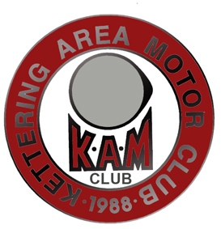
IN CONJUNCTION WITH THE
FEDERATION OF BRITISH HISTORIC VEHICLE CLUB’S IN CONJUNCTION WITH THE
FEDERATION OF BRITISH HISTORIC VEHICLE CLUB’S
“DRIVE IT DAY”
THE KETTERING AREA MOTOR CLUB
and the
THE CITROEN SPECIALS CLUB

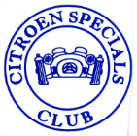

Drivers Name

Passengers Name(s):

Address:

Post Code:

Telephone Number: Mbl:

Email

Your Vehicle Make: Model :

Year Registered: Registration No

£

Number of Adults in party: (Cost per adult: £2.50) Total Cost :-
(under 16’s go free):
Cost per vehicle :-
£
£ 2.00
Late entry fee (£5 Where applicable)
£
GrandTotal :-

Please make your cheque payable to :- S C A A F (Stilton Cheese Air Ambulance Fund)

Do you require disabled parking (Yes/No) Do You Require a Certificate (Yes/No)

And send it with a stamped (second class), self addressed C5 23cmx16cm (6-1/4 inches x 9 inches) envelope If you use the wrong envelope/stamp combination it will not get delivered. You have been warned. to:- Jim Barry, 164 Polwell Lane, Barton Seagrave, Kettering, Northants. NN15 6UB. Tel: 01536 724512 (Mbl: 07952 398638)
Email jim.barry@ntlworld.com
Entries to be received by April 10th 2018 please. Entries received after this date will be subject to availability and an additional charge of £5.00. Please phone or email to check availability.

